**ASSISTED PRACTICE (HTTP, FTP, JAVA, JDBC)**

HTTP:

Step1: Open Jmeter

Step2: Right click on Test Plan -> Click on Thread(Users) -> Thread Group

Step3: On Thread Group, Give the number of users as 100, Ramp-up period as 100, Number of iterations as 10 and save it

Step4: Right click on Thread Group -> Sampler -> Add Http Request

Step5: On Http request, give the name to it, Give the url of website we want to test in “Server name or IP” section and put “/” in Path and save it

Step6: Right click on Thread Group -> Add -> Listeners -> View Results Tree (to see the output) as shown below:

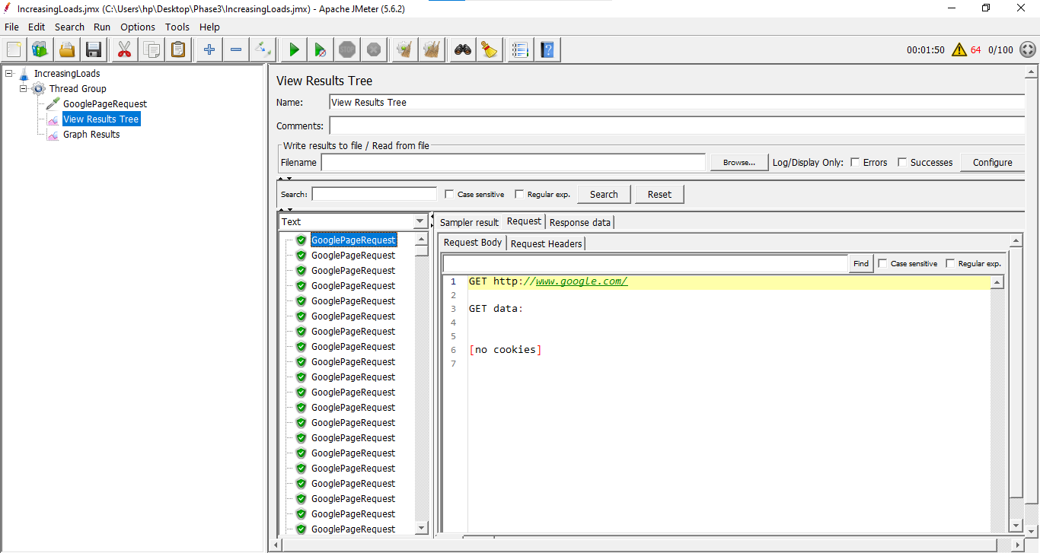

FTP:

Step1: Download filezilla Client

Step2: Give these FTP server details in filezilla :

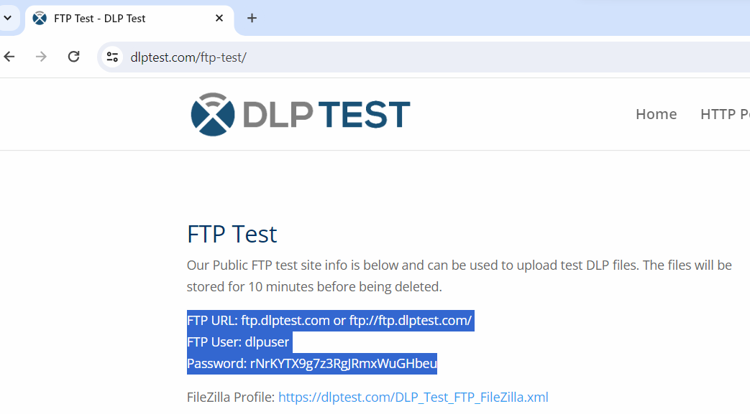

Step3: Create file in any folder on our machine

Step4: Now in filezilla we will find our file in the folder

Step5: Upload the file in remote directory(Right click on file and click on upload -> It will go to the remote directory in filezilla)

Step6: Now, remove that file from our server in filezilla (Check that file should also be deleted from our folder where we have saved that file in our machine)

Step7: Open Jmeter -> Add Thread Group

Step8: Right click on Thread Group -> Add -> Sampler -> FTP Request

Step9: In FTP request, Give the server name as same as we have given in filezilla, In remote file Give the path of our file as “/name of our file”, In Local File, Give the path of our folder where we have saved that file and Give the same username and password that we have given in filezilla

Step10: Right click on Thread Group -> Add -> Listener -> View results tree (to see the output) as shown below:

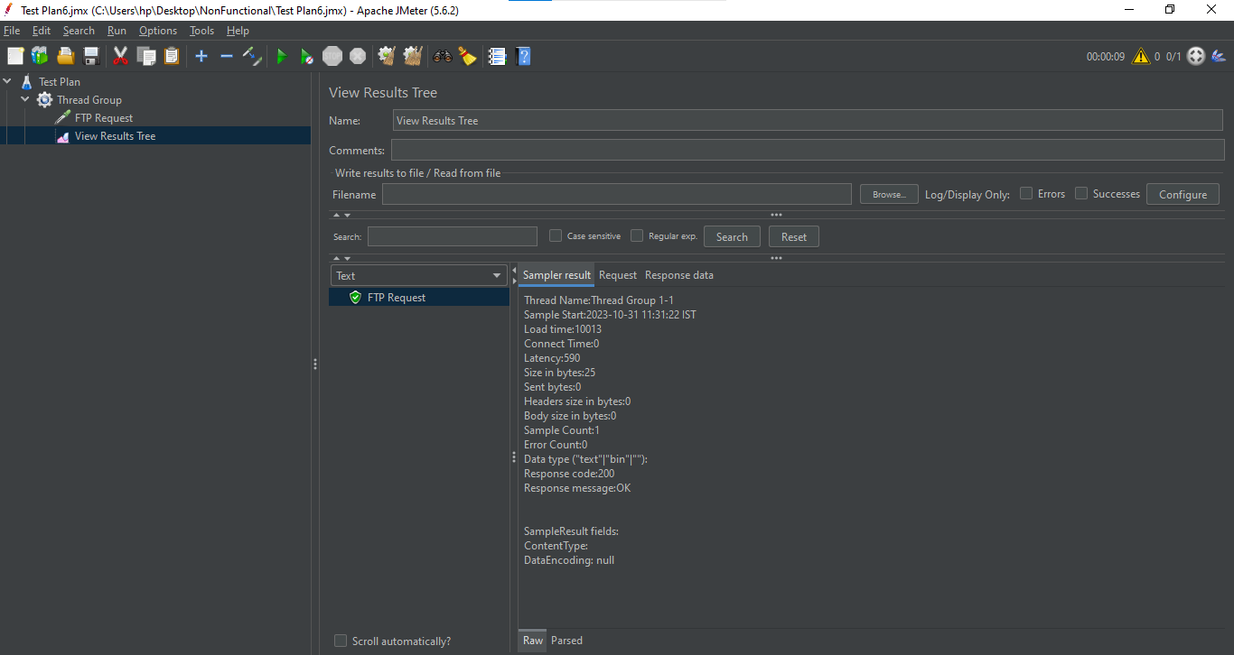

JAVA:

Step1: Open Jmeter -> Add Thread Group

Step2: Right click on Thread Group -> Add -> Config elements -> Random Variable

Step3: In Random Variable, Give the values as shown below:

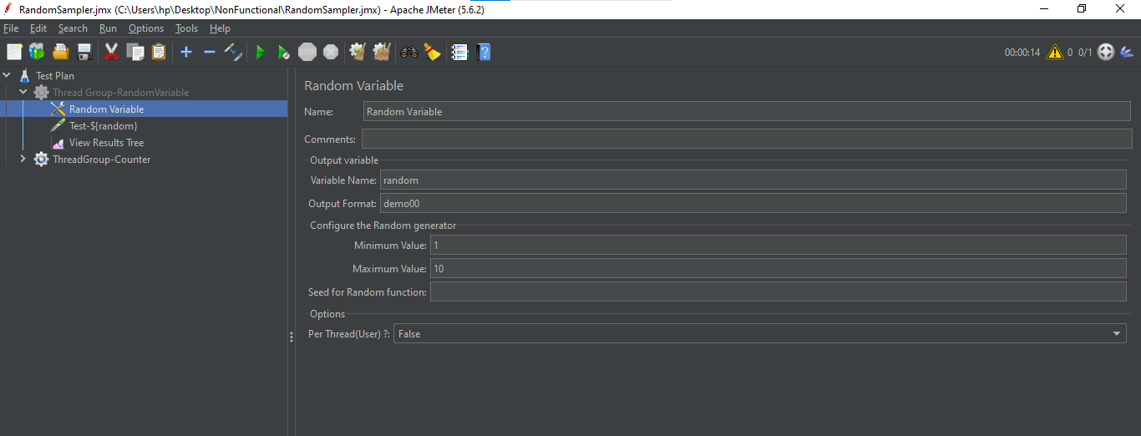

Step4: Right click on Thread Group -> Add -> Sampler -> Java Request

Step5: Give the name of Java Request as shown below:

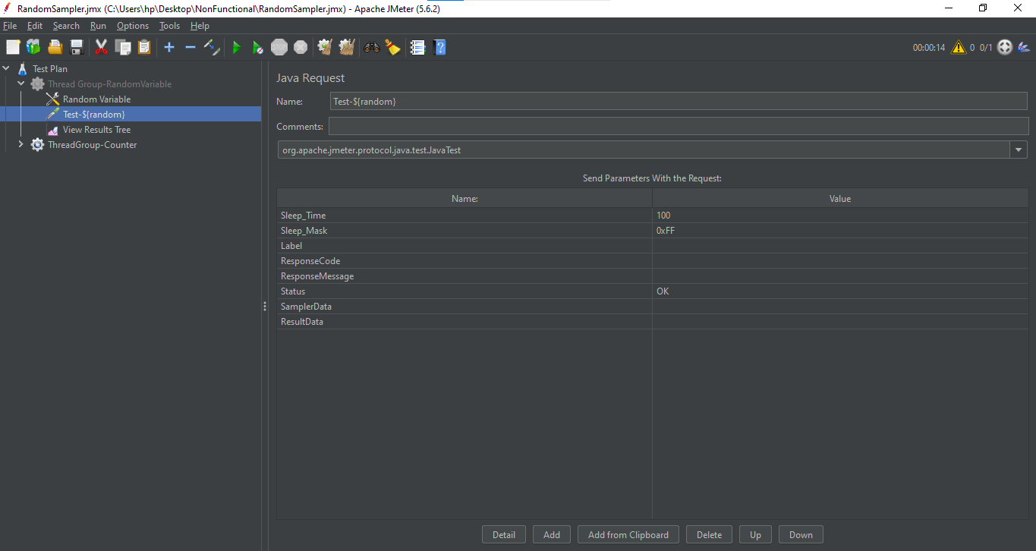

Step6: Right click on Thread Group -> Add -> Listener -> View Results Tree (to see the output)

Step7: Save it and execute

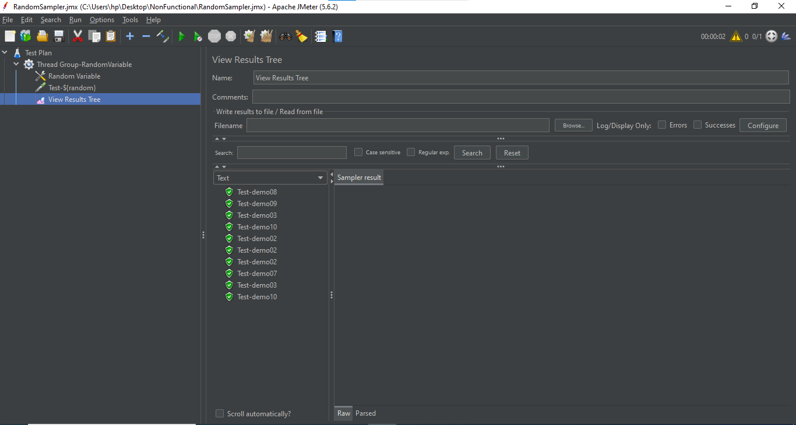

JDBC:

Step1: Download the JDBC Connector jar file

Step2: Open the browser and type this url <https://dev.mysql.com/downloads/connector/j/> and press enter

Step3: In the drop down select platform independent -> Select the second option : Platform Independent (Architecture Independent), ZIP -> Click on download button

Step4: On next page click on -> No thanks, just start my download -> Zip file will be downloaded

Step5: Now go to downloads folder of our laptop -> right click on zip file and click on extract here -> In the folder there will be a JDBC connector.jar file

Step6: This Jar file has to be copied and pasted in our Jmeter folder -> lib folder

Step7: After copying the jar file in lib folder -> restart our apache Jmeter (close it and start it again)

Step8: In Jmeter -> create a Thread group -> Add -> Config Element -> JDBC connection Configuration

Step9: Add the variable pool name and add DB connection details

Step10: Thread group -> Add the JDBC request -> Add the variable name as given in JDBC configuration -> Add the query to be executed

Step11: Right click on Thread Group -> Add -> Listener -> View Results Tree (to see the output) as shown below:

